

**CSE2007 : Database Management Systems**

**Name :** Gudi Varaprasad

**Reg. No. :** 19BCE7048

School of Computer Science and Engineering

**Lab Slot :** L45 + L46

**Date :** 03 – 06 – 2021

**Submitted to :** Ms. Dhanavanthini madam

**Practice Lab Exercises on a Database**

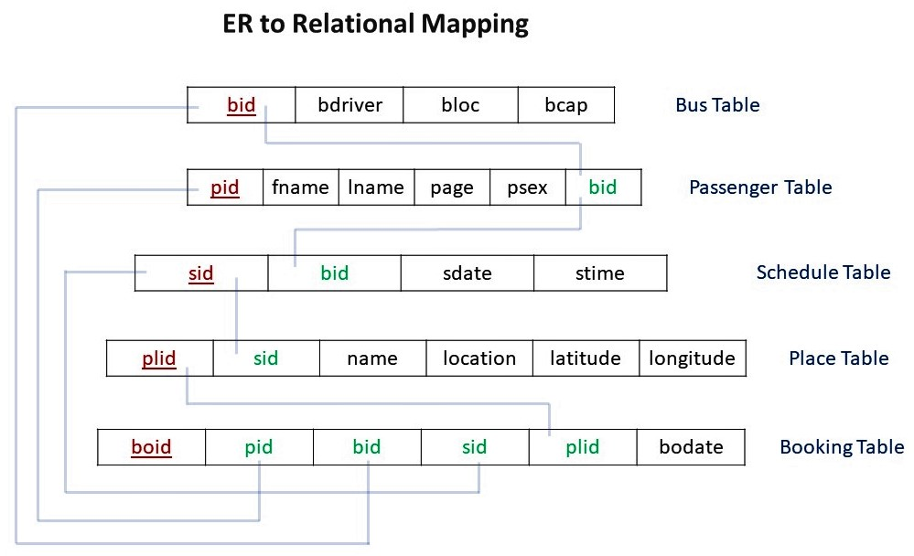

**Consider the above given relations : (Travel Database)  
  
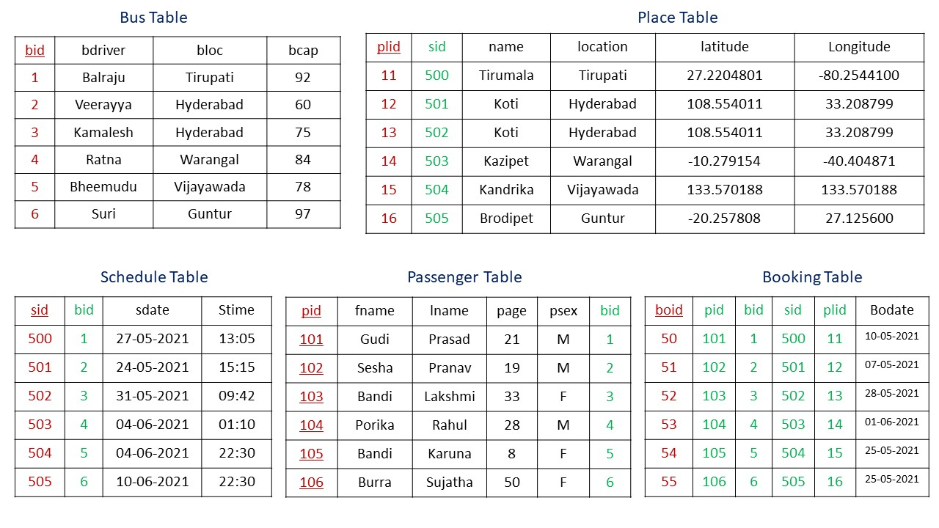**

**Answer the following Queries using above tables :**

**1. Create table Bus with attributes bid, bdriver, bloc, bcap.**

> CREATE TABLE Bus(bid number(1) NOT NULL, bdriver varchar2(8), bloc varchar2(10), bcap number(2), PRIMARY KEY(bid));



**2. Create table Passenger with attributes pid, fname, lname, page, psex, bid.**

> CREATE TABLE Passenger(pid number(3) NOT NULL, fname varchar2(6), lname varchar2(7), page number(2), psex varchar2(1), bid number(1), PRIMARY KEY(pid), FOREIGN KEY(bid) REFERENCES Bus);

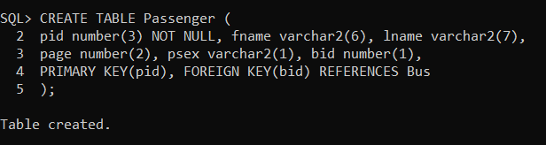

**3. Insert the data given above in all the tables given above.**

> INSERT INTO Bus VALUES(&bid, '&bdriver', '&bloc', &bcap);

> INSERT INTO Passenger VALUES(&pid, '&fname', '&lname', &page, '&psex', &bid);

> INSERT INTO Schedule VALUES(&sid, &bid, '&sdate', '&stime');

> INSERT INTO Place VALUES(&plid, &sid, '&name', '&location', &latitude, &longitude);

> INSERT INTO Booking VALUES(&boid, &pid, &bid, &sid, &plid, '&bodate');  
  
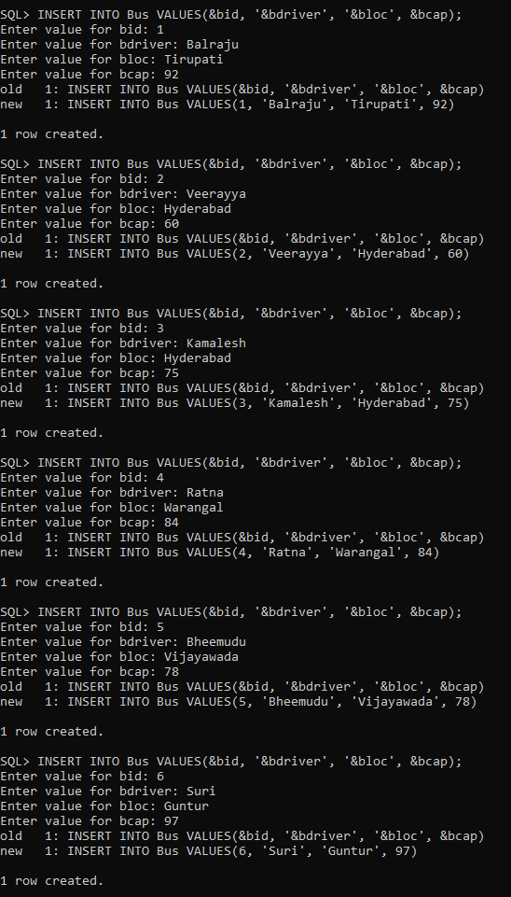 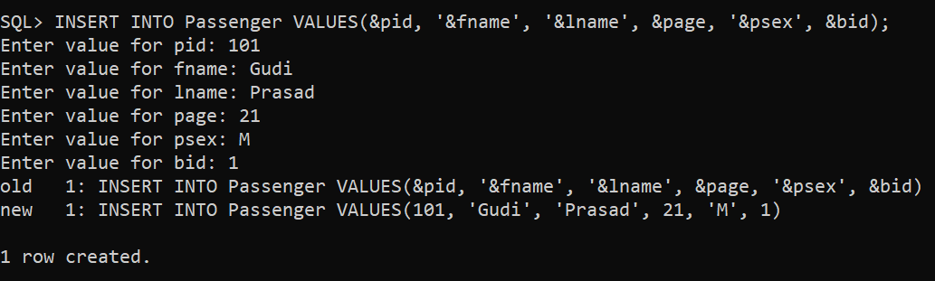

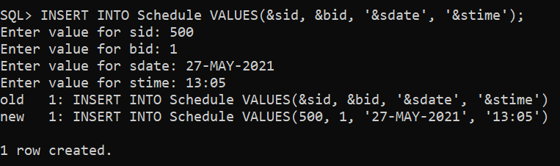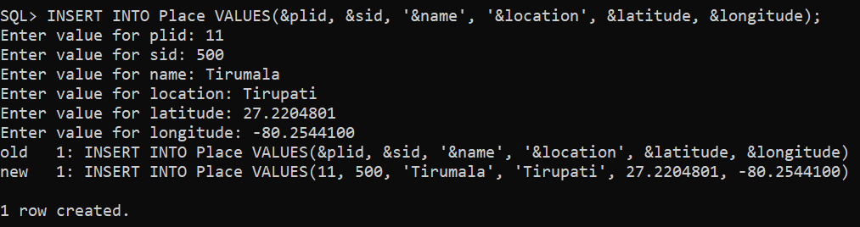

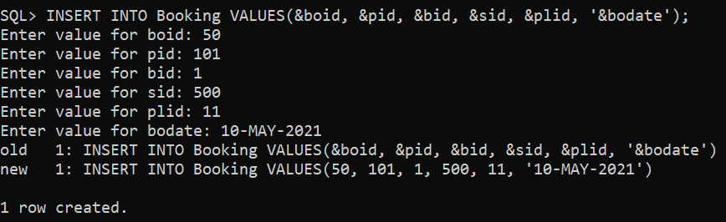

**4. Display all the passenger’s information.**

> SELECT * FROM Passenger;

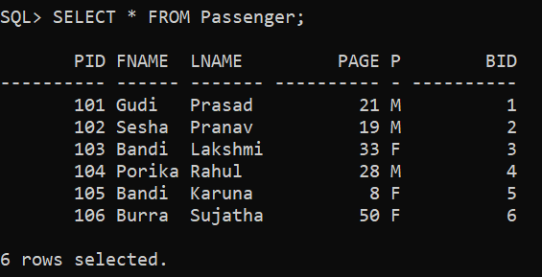

**5. Display passenger lname along with his pid, bus bid.**

> SELECT pid, bid, lname FROM Passenger;

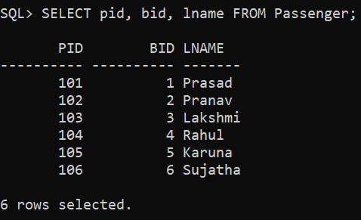

**6. Display the passenger names whose age is above 18.**

> SELECT fname, lname FROM Passenger WHERE page>18;

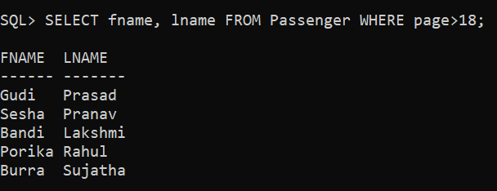

**7. Display gender of passengers without duplication.**

> SELECT DISTINCT psex AS Gender FROM Passenger;

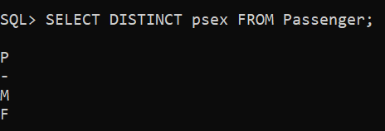

**8. Display bid, sdate of the bus scheduled to Vijayawada.**

> SELECT DISTINCT Bus.bid, Schedule.sdate FROM Bus JOIN Schedule ON Bus.bid=Schedule.bid WHERE Bus.bloc='Vijayawada';

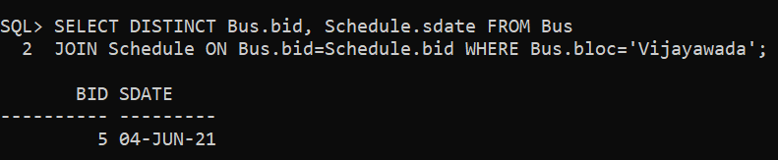

**9. Modify bid of passenger having fname as ‘Burra’ to 3.**

> UPDATE Passenger SET bid=3 WHERE fname='Burra';

> SELECT * FROM Passenger;

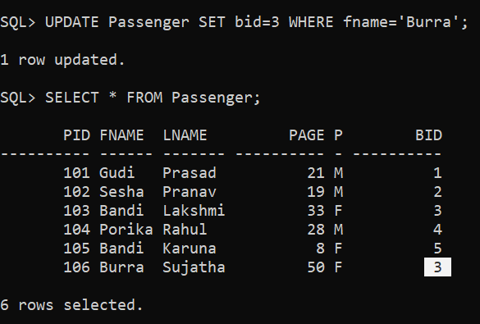

**10. Alter table Passenger add column ‘mobile’ of NUMBER data type and insert values into this column only.**

> ALTER TABLE Passenger ADD mobile number(10);

> UPDATE Passenger SET mobile=9391589364 WHERE pid=101;

> UPDATE Passenger SET mobile=9715089301 WHERE pid=102;

> UPDATE Passenger SET mobile=8091539340 WHERE pid=103;

> UPDATE Passenger SET mobile=6300148711 WHERE pid=104;

> UPDATE Passenger SET mobile=7386661270 WHERE pid=105;

> UPDATE Passenger SET mobile=8844122571 WHERE pid=106;

> SELECT * FROM Passenger;

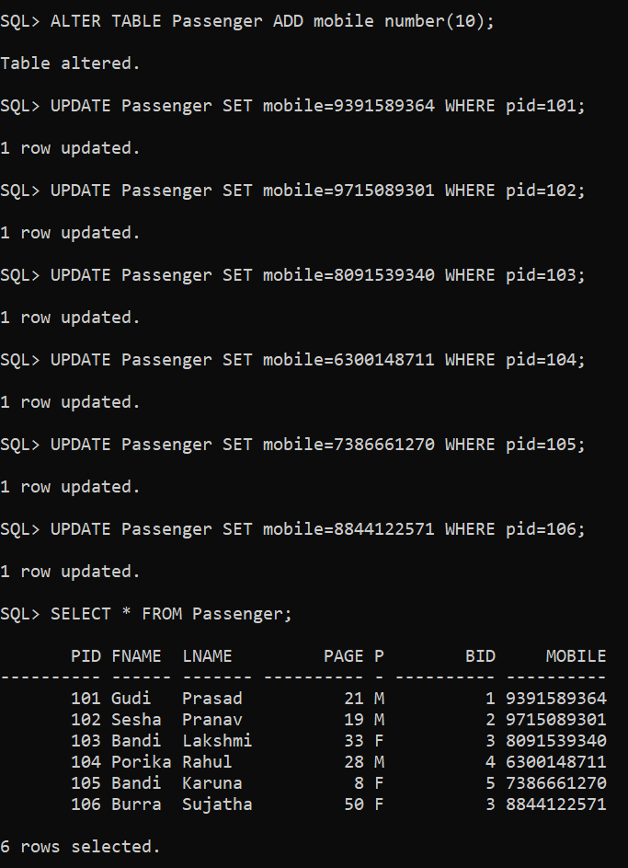

**11. Alter table Passenger to modify the size of column ‘mobile’.**

> ALTER TABLE Passenger MODIFY mobile number(11);  
  
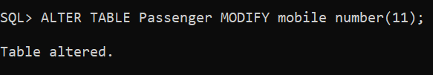

**12. Modify the field name ‘mobile’ of Passenger table to ‘phone’.**

> ALTER TABLE Passenger RENAME COLUMN mobile TO phone;

> DESC Passenger;

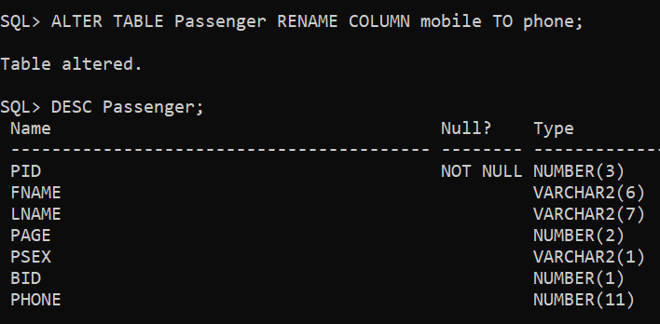

**13. Rename table ‘Bus’ as ‘Vehicle’.**

> RENAME Bus TO Vehicle;

> DESC Vehicle;

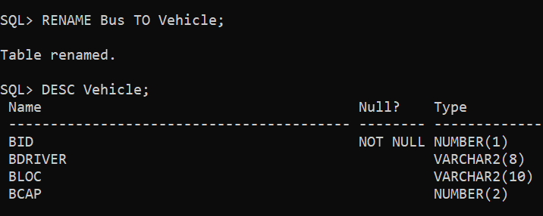

**14. Alter table Passenger remove column ‘phone’.**

> ALTER TABLE Passenger DROP COLUMN phone;

> DESC Passenger;

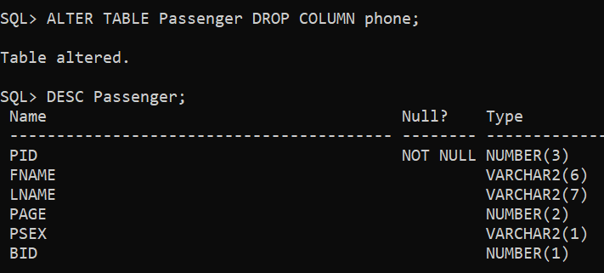

**15. Create a table ‘CopyOfVehicle’ as a copy of the table Vehicle.**

> CREATE TABLE CopyOfVehicle AS SELECT * FROM Vehicle;

> SELECT * FROM Vehicle;

> SELECT * FROM CopyOfVehicle;

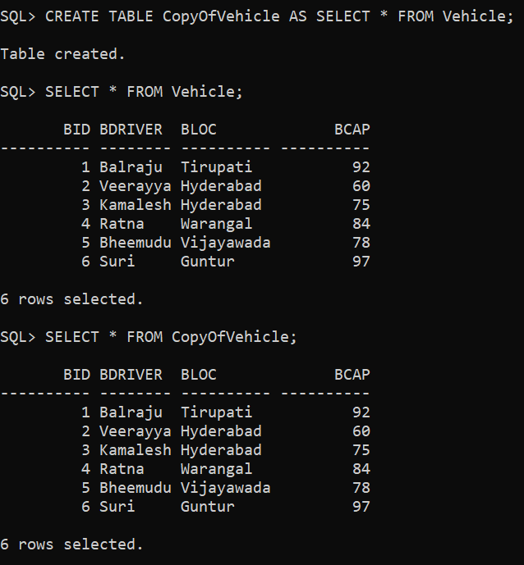

**16. Delete all the rows from ‘CopyOfVehicle’ table.**

> DELETE FROM CopyOfVehicle;

> SELECT * FROM CopyOfVehicle;

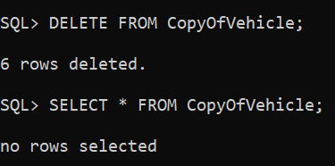

**17. Remove ‘CopyOfVehicle’ table.**

> DROP TABLE CopyOfVehicle;

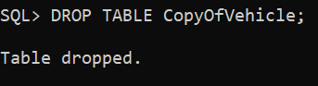

**18. Display all the passengers in descending order based on their age.**

> SELECT * FROM Passenger ORDER BY page DESC;

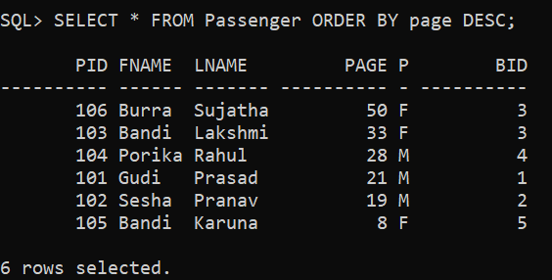

**19. How many male, female and total passengers are travelling.**

> SELECT COUNT(case when psex='M' then 1 end) as male, COUNT(case when psex='F' then 1 end) as female, COUNT(*) as total FROM Passenger;

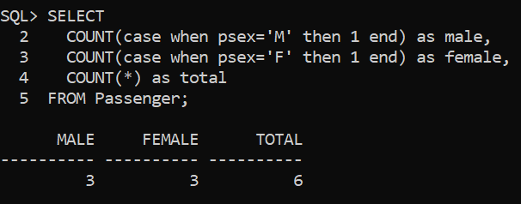

**20. Find the passenger lname whose bus booking date was 25-05-2021.**

> SELECT Passenger.lname FROM Passenger JOIN Booking ON Passenger.pid=Booking.pid WHERE Booking.bodate='25-May-2021';

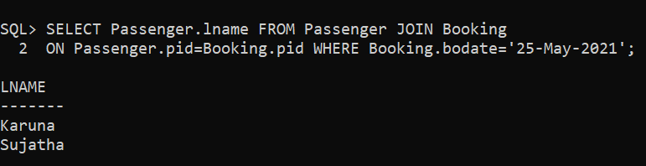

**21. Find the passenger lname whose bus capacity is between or equal 80 and 100.**

> SELECT Passenger.fname FROM Passenger JOIN Bus ON Passenger.bid=Bus.bid WHERE Bus.bcap>=80 AND Bus.bcap<=100;

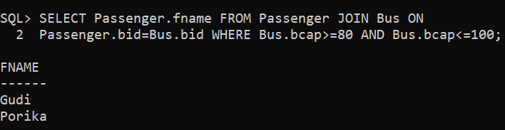

**22. Find the passenger fname and gender who have bus driver as ‘Balraju’.**

> SELECT Passenger.fname, Passenger.psex FROM Passenger JOIN Bus ON Passenger.bid=Bus.bid WHERE Bus.bdriver='Balraju';

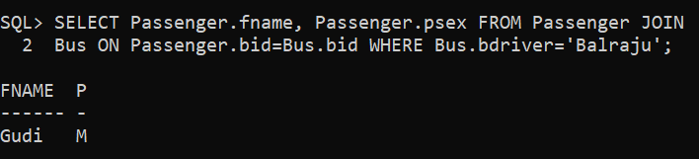

**23. Display sdate of all busses in the format ‘DDthMonthYYYY’.**

> SELECT TO_CHAR(sdate, 'DDth Month YYYY') AS DDth_Month_YYYY FROM Schedule;

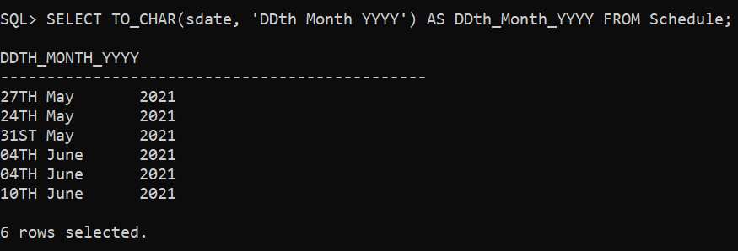

**24. Display bus driver names whose bus is scheduled on or before 4th June 2021.**

> SELECT Bus.bdriver FROM Bus JOIN Schedule ON Bus.bid=Schedule.bid WHERE Schedule.sdate<='04-JUNE-2021';

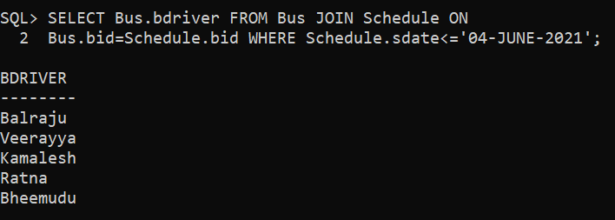

**25. Display passenger fname, lname whose destination is to ‘Koti’.**

> SELECT Passenger.fname, Passenger.lname FROM Passenger JOIN Schedule ON Passenger.bid=Schedule.bid JOIN Place ON Schedule.sid=Place.sid WHERE Place.name='Koti';

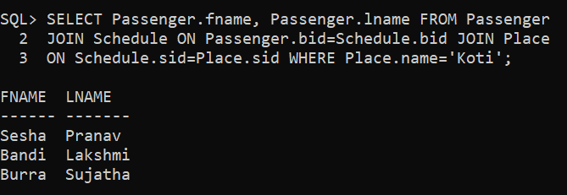

**26. Display the bus driver name that starts with ‘B’.**

> SELECT bdriver FROM Bus WHERE bdriver LIKE 'B%';

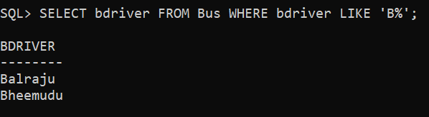

**27. Display the bus driver name that ends with ‘a’.**

> SELECT bdriver FROM Bus WHERE bdriver LIKE '%a';

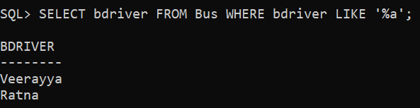

**28. Display all the names of passengers whose bus driver with any of the following bid 2, 3.**

> SELECT Passenger.pid, Passenger.fname, Passenger.lname FROM Passenger JOIN Bus ON Passenger.bid=Bus.bid WHERE Bus.bid=2 OR Bus.bid=3;

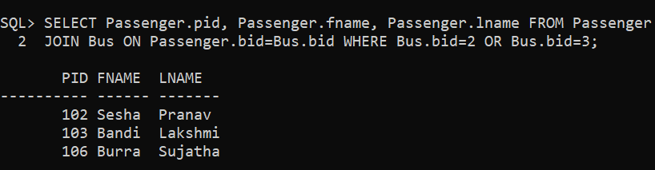

**29. Display all the location names in Place table in UPPER CASE and in lower case.**

> SELECT UPPER(name) AS Caps, LOWER(name) AS Small FROM Place;

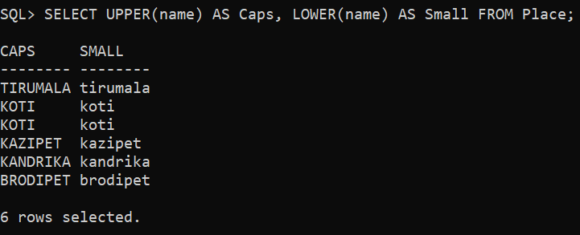

**30. Display the first three characters and last three of names in the Place table using substring function.**

> SELECT SUBSTR(name,1,3) AS first, SUBSTR(name,-3) AS last FROM Place;

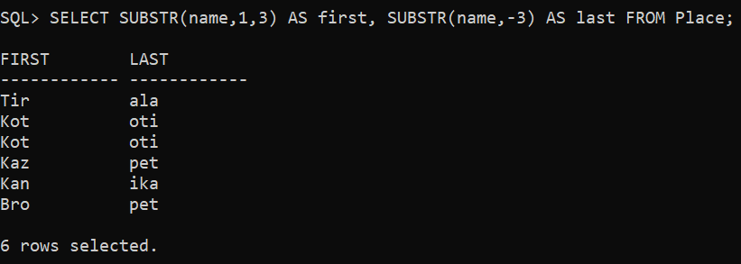

**31. Display the substring of the bloc (starting from 2nd position to 5th position) of all in Bus table.**

> SELECT SUBSTR(bloc,2,5) AS subloc FROM Bus;

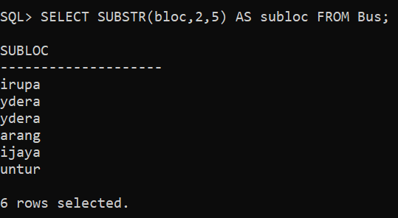

**32. Display sdate on adding five months to it.**

> SELECT sdate AS before, TRUNC(ADD_MONTHS(sdate, 5)) AS After FROM Schedule;

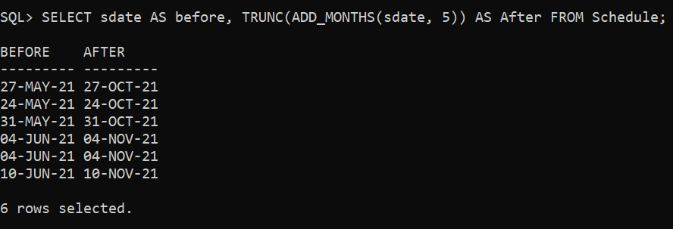

**33. Display longitude of all the locations rounded to 3 decimals.**

> SELECT ROUND(longitude, 3) AS roundoff FROM Place;

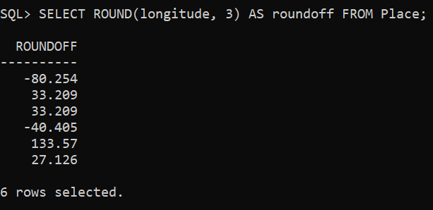

**34. Find the last day and next day of the month in which each passenger has booked a bus.**

> SELECT LAST_DAY(bodate) AS lastday, NEXT_DAY(bodate, 1) AS nextday FROM Booking;

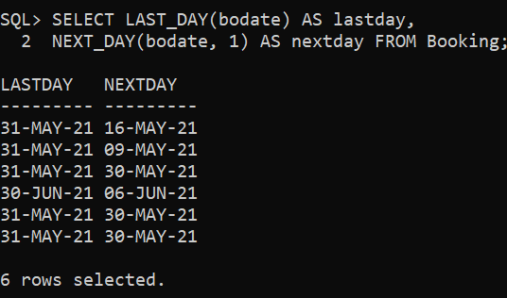

**35. Print a substring from the string ‘Varaprasad’.**

> SELECT SUBSTR('VARAPRASAD',5,10) AS gvp FROM dual;

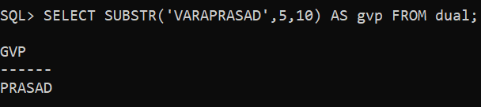

**36. Replace the string ‘Vara’ from ‘Varaprasad’ by ‘Hari’.**

> SELECT REPLACE('VARAPRASAD','VARA','HARI') AS gvp FROM dual;

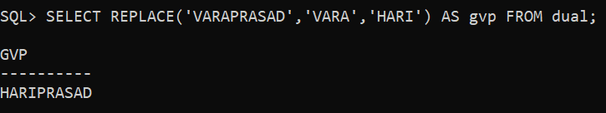

**37. Print the length of all the location names.**

> SELECT location, LENGTH(location) AS length FROM Place;

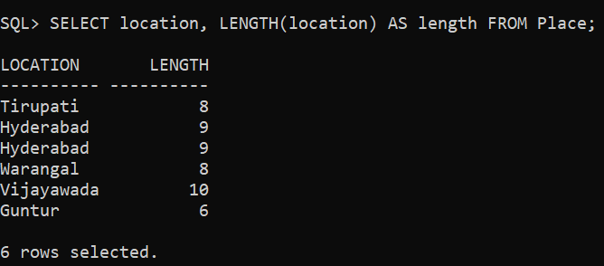

**38. Print the booking date in the format 2021/05/25.**

> SELECT TO_DATE(bodate, 'YYYY/MM/DD') AS format FROM Booking;

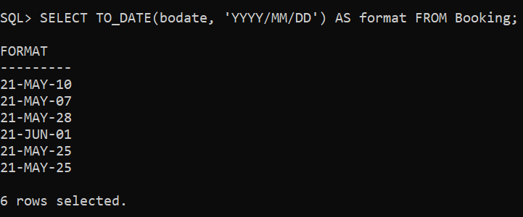

**39. Display the date after 6 months from current date.**

> SELECT SYSDATE AS before, TRUNC(ADD_MONTHS(SYSDATE, 6)) AS After FROM dual;

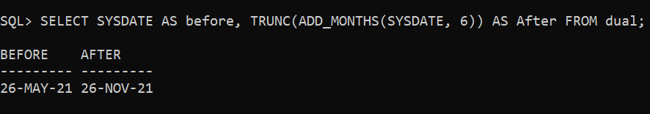

**40. Display the next occurrence of Monday in this month.**

> SELECT SYSDATE AS before, NEXT_DAY(SYSDATE, 'Monday') AS After FROM dual;

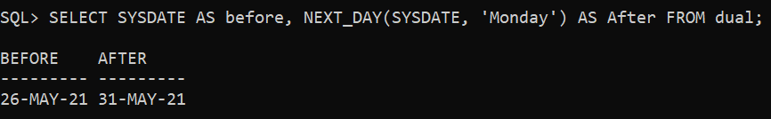

**41. How many different locations are there in Place table.**

> SELECT COUNT(DISTINCT location) FROM Place;

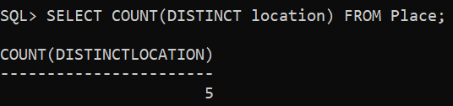

**42. For each location display minimum and maximum age of passenger travelling.**

> SELECT MAX(Passenger.page) AS maximum, MIN(Passenger.page) AS mimimum FROM Passenger JOIN Schedule ON Passenger.bid=Schedule.bid JOIN Place ON Schedule.sid=Place.sid GROUP BY location;

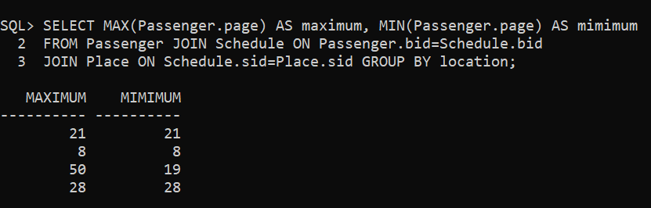

**43. Print the average bus capacity.**

> SELECT AVG(bcap) AS average FROM Bus;

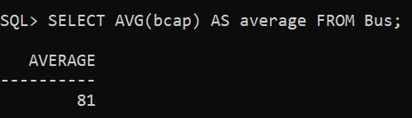

**44. Count the number of passengers over 20 age.**

> SELECT COUNT(DISTINCT page) FROM Passenger WHERE page>20;

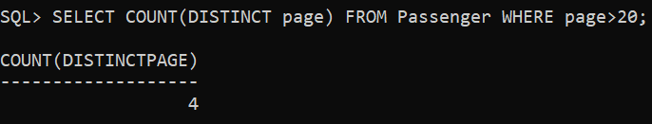

**45. Print the passenger lname whose bus scheduled is today.**

> SELECT Passenger.lname FROM Passenger JOIN Schedule ON Passenger.bid=Schedule.bid WHERE Schedule.sdate=SYSDATE;

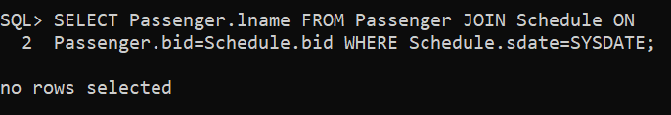

**46. Create a view to display the place details whose booking is on 25-05-2021**

> CREATE TABLE new_booking AS SELECT Place.plid, Place.name, Place.location, Place.latitude, Place.longitude FROM Place JOIN Booking ON Place.plid=Booking.plid WHERE Booking.bodate='25-May-2021';

> SELECT * FROM new_booking;

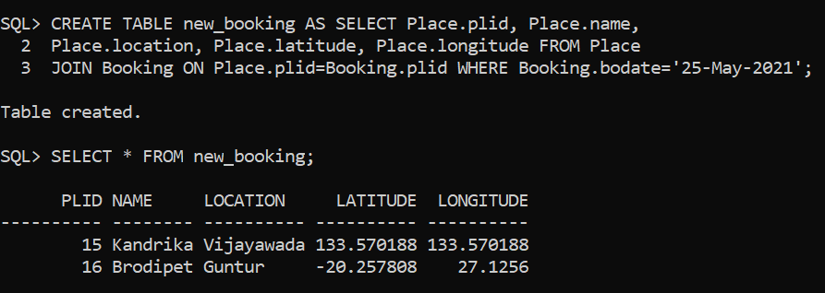

**47. Create a logical table to store required details who booked a bus capacity more than 80.**

> CREATE TABLE new_bus AS SELECT Passenger.pid, Passenger.fname, Passenger.lname, Passenger.page, Passenger.psex, Bus.bcap FROM Passenger JOIN Bus ON Passenger.bid=Bus.bid WHERE Bus.bcap>80;

> SELECT * FROM new_bus;

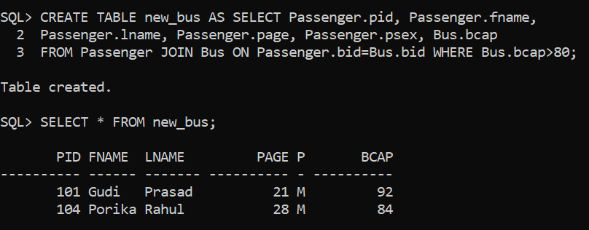

**48. Create a table to store the passenger details based on booking date.**

> CREATE TABLE new_passenger AS SELECT Passenger.pid, Passenger.fname, Passenger.lname, Passenger.page, Passenger.psex, Booking.bodate FROM Passenger JOIN Booking ON Passenger.pid=Booking.pid;

> SELECT * FROM new_passenger;

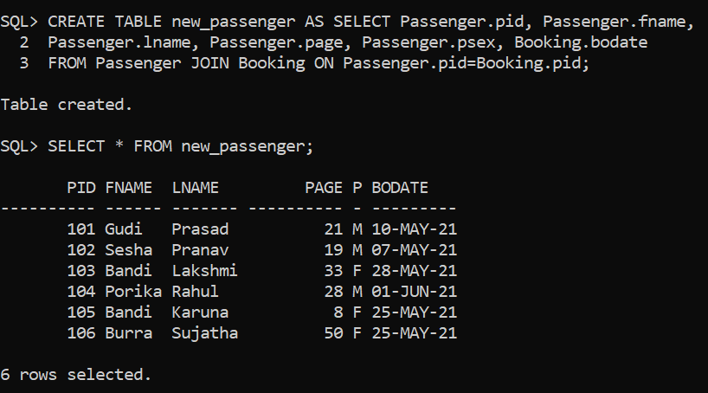

**49. Print the bus driver name corresponding passenger name and his destination who booked a bus on 28-05-2021.**

> SELECT Bus.bdriver, Passenger.lname, Place.name FROM Bus JOIN Passenger ON Bus.bid = Passenger.bid JOIN Booking ON Booking.pid = Passenger.pid JOIN Place ON Booking.plid=Place.plid WHERE Booking.bodate = '28-MAY-2021';

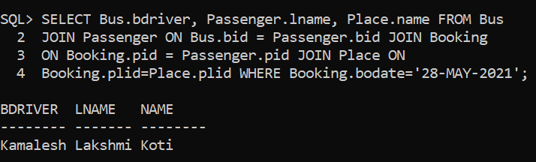

**50. Display all details who is travelling to place ‘Kazipet’ and when and when is it booked ?**

> SELECT Passenger.pid, Passenger.lname, Bus.bid, Place.name, Schedule.sdate, Booking.bodate FROM Bus JOIN Passenger ON Bus.bid = Passenger.bid JOIN Schedule ON Passenger.bid = Schedule.bid JOIN Place ON Schedule.sid=Place.sid JOIN Booking ON Place.plid=Booking.plid WHERE Place.name='Kazipet';

